# Goal

The purpose of this assignment is to showcase your skills in analyzing business needs and in utilizing Python and SQL to provide solutions.

# Assignment

Scenario:

Company XYZ held a promo sale for their signature items named: x,y,z. Sales are at an

all-time high, but they want to create a marketing strategy to target age groups of people by looking at total quantities purchased.

They then created a database with these business rules:

* A sales receipt can have multiple items in an order.
* For every order, the clerk records all quantities for all items, including items not bought (which they denote with quantity=NULL).
* Each customer can do multiple sales transactions, and has his/her age stored in a database.

Refer to the image below for the table structures and relationships.

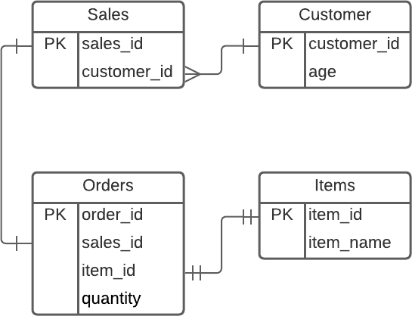

Objectives

Create a Python script that can:

1. connect to the SQLite3 database provided
2. extract the total quantities of each item bought per customer aged 18-35.
   * For each customer, get the sum of each item
   * Items with no purchase (total quantity=0) should be omitted from the final list
   * No decimal points allowed (The company doesn’t sell half of an item ;) ) Challenge: Provide 2 solutions, one using purely SQL, the other using Pandas
3. store the query to a CSV file, delimiter should be the semicolon character (';')

Test case:

Customer 1 bought Item X on multiple occasions, totaling 10 for Item X only Customer 2 bought one of each item only once, totaling 1 each Item Customer 3 bought Item Z on two occasions, totaling 2 for Item Z only

Then the output file should look like the example below:

Customer;Age;Item;Quantity 1;21;x;10

2;23;x;1

2;23;y;1

2;23;z;1

3;35;z;2

(Note: Actual values will vary)

# Delivery

Provide a link to a public repository where we can download the code containing all files.